Aspen Neff
New York, NY | (440) 305-4569 | aspenneff05@gmail.com
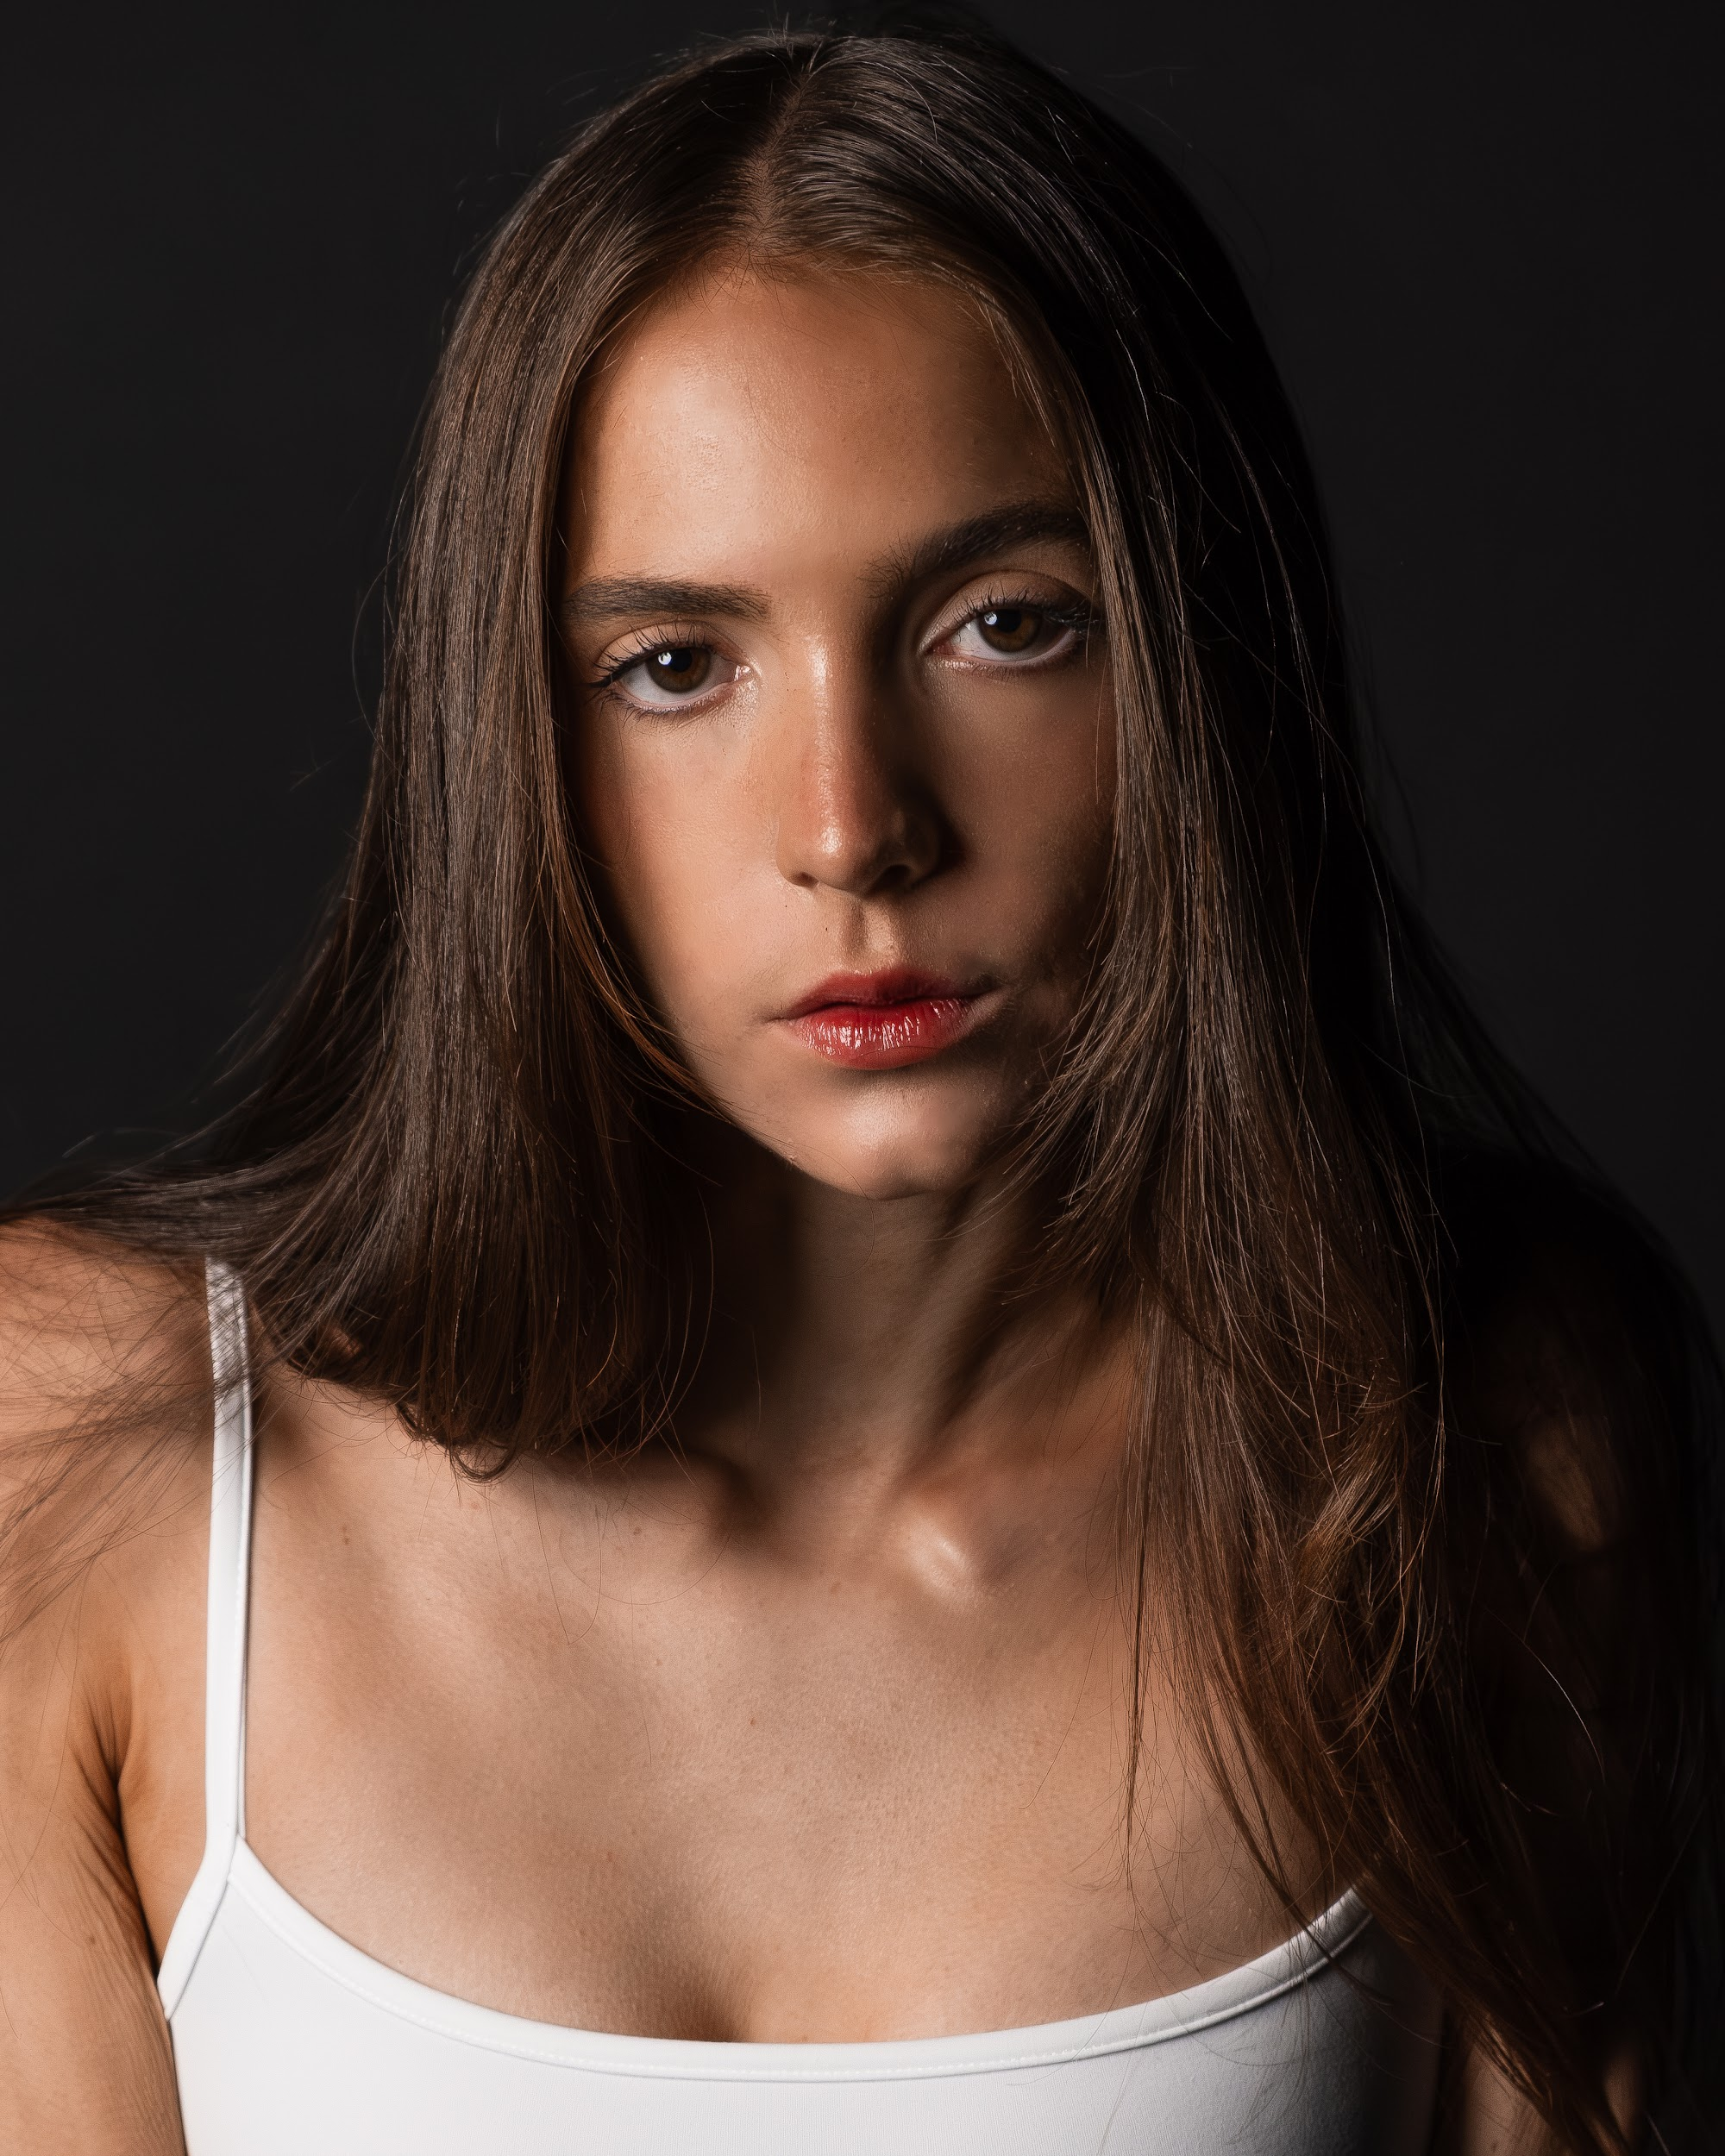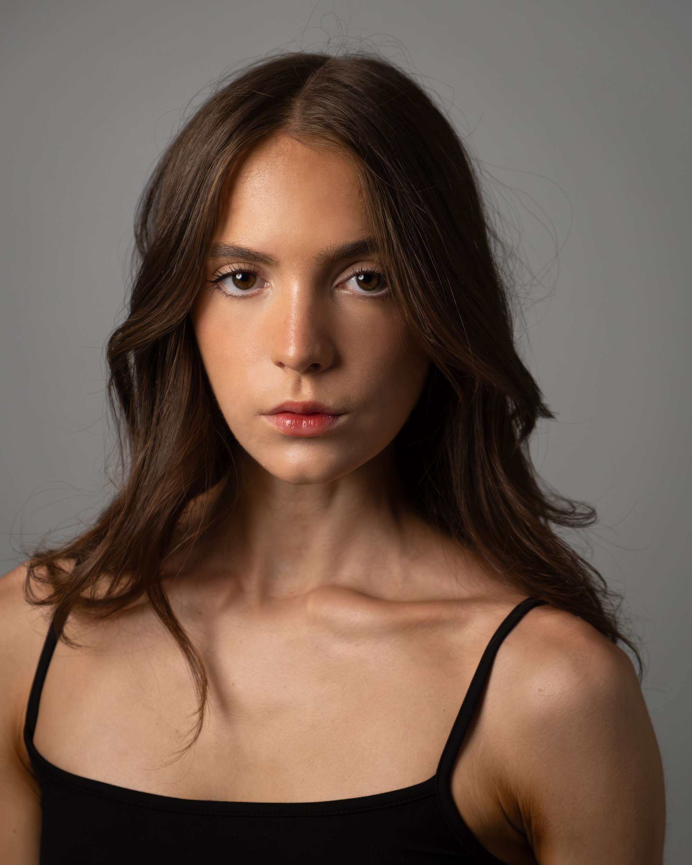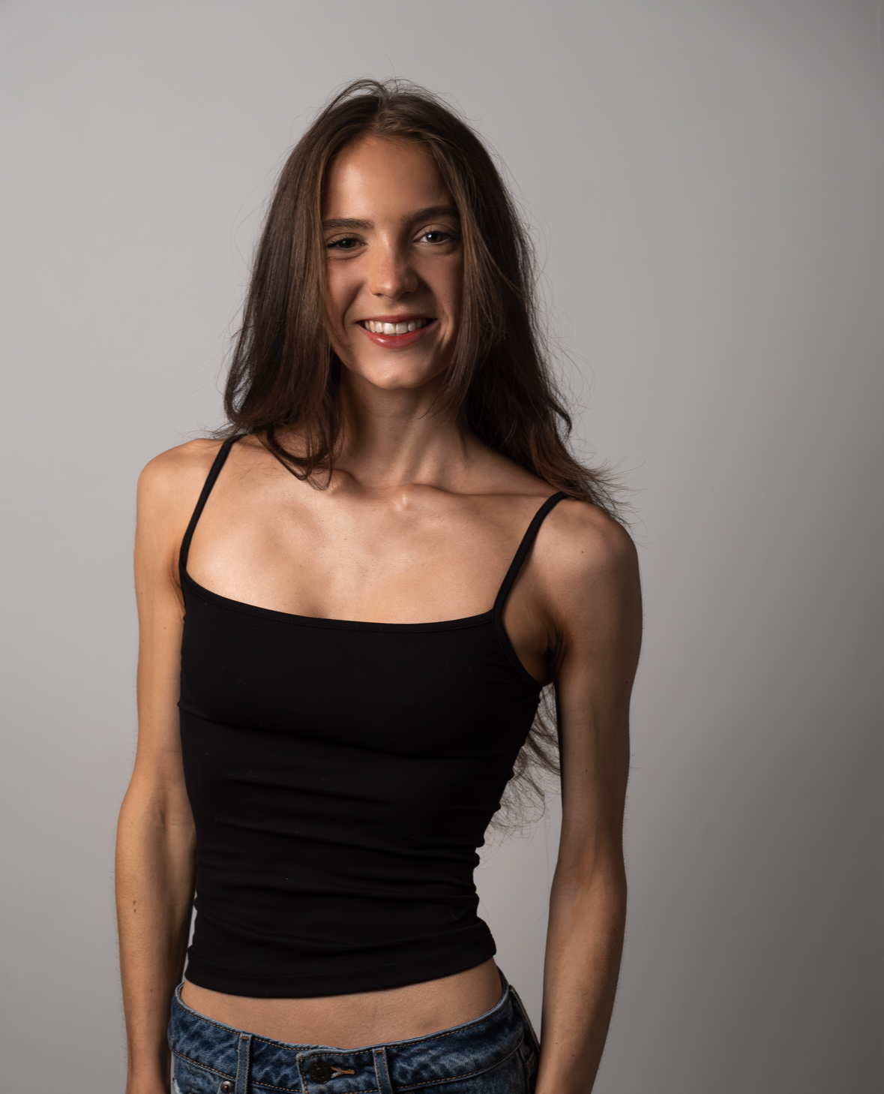

EDUCATION

New York University Tische School of Arts, September 2024- Present
Drama and Film

Stella Adler Studio of Acting September 2024- Present

FILM ACTING EXPERIENCE____________________________________________________________________
10 Things I Hate About Ya Kate (Lead) Shana Kolev
New York University, 2025

Modern Family Hailey (Lead) Kiara Gabel
New York University, 2025

The Manual Margarette (Lead) Shana Kolev

Trying to Study Student (Lead) Dr. Rashad T. Goldsborough

The Rashad T. Goldsborough Company LLC, USC 2025

The Choice Arts Student (Lead) Dr. Rashad T. Goldsborough

The Rashad T. Goldsborough Company LLC, USC 2025

Un/Known Caller Amy (Lead) Renee Fournell
New York University, 2025

Anxiety Amy (Lead) Sophia Goldsmith
New York University, 2025

Run Final Girl (Lead) Sophia Goldsmith
New York University, 2025

Last Party Girl (Lead) Musa Shraff
New York University, 2025

Trust The System Keres (Lead) London Burden
New York University Funded Feature Films, 2025

Boy Toy Lily (Lead) Vienna Skinnel
Femme Fatale Productions
Film First Productions, 2024

Pick Extra 1 Kiara Sanchez
New York University, 2024

Girlfriend Auditions Girl 1 Melis Turkengench
New York University, 2024

Movie Talk Broadcaster Les Szekeley
WHBS 2023

FILM & PRODUCTION EXPERIENCE __________________________________________________________________________
Editing Eric Juhola May 2025- July 2025
New York University

Assistant Director Eric Juhola May 2025- July 2025
New York University

Directing Eric Juhola May 2025- July 2025
New York University

Writing Eric Juhola May 2025- July 2025
New York University

Post Production Eric Juhola May 2025- July 2025
New York University

Foundations of Film Eric Juhola May 2025- July 2025
New York University

Editing Philip DeRise September 2023- November 2023
New York University

Producing Philip DeRise September 2023- November 2023
New York University

Documentary Philip DeRise September 2023- November 2023
New York University

Music Video Philip DeRise September 2023- November 2023
New York University

Westlake Film Media Manager Westlake High School 2021-2023

Westlake Film: News Producer Westlake High School 2021-2023

Westlake Film: News Broadcaster Westlake High School 2021-2023

Westlake Film: Editor Westlake High School 2021-2023

Editor in Chief Westlake High School 2021-2023

THEATER EXPERIENCE __________________________________________________________________________ __
Children of Eden Stage Manager Michelle Cha
Counterpoint Studios, 2023

It’s a Wonderful Life Student Director Aspen Neff and Doug Warnke
Westlake High School, 2023

Spongebob Stage manager Michelle Cha
Counterpoint, 2023

Legally Blonde Brooke Windham Jennifer Butler
Westlake High School, 2023

Annie in Concert Miss Hannigan Sarah Demetruk
Cleveland Play House, 2023

Into the Woods Witch Jeff Lockshine
Counterpoint Studios, 2022

The Christmas Carol Bob Cratchit Douglas Warnke
Westlake High School, 2022

Mamma Mia! Sophie Sheridan Michelle Cha
Counterpoint Studios, 2022

Chicago Liz (Pop) Jennifer Butler
Westlake High School, 2022

Newsies Wiesel/Nun/Featured Dancer Michelle Cha
Counterpoint Studios, 2021

The Addams Family Ancestor/Featured Dancer Jennifer Butler
Westlake High School, 2021

The Sound of Music The Baroness Michelle Cha
Counterpoint Studios, 2020

Oklahoma Child Ensemble Jennifer Butler
Westlake High School, 2019

Into the Woods Lucinda Angela Boehm
Olmsted Performing Arts, 2018

The Wizard of Oz Munchkin Jennifer Butler
Westlake High School, 2011

APPLIED STUDY___________________________________________________________________ ______

Acting:

Stella Adler NYU 2

Technique Antonio Merenda September 2025- 2026
Scene Study Tyrone Henderson September 2025- 2026
Shakespeare Verse Angela Vitale September 2025- 2026
Shakespeare Ian Hersey September 2025- 2026
Movement Joanne Edelmann September 2025- 2026
Voice and Speech Cato Crumbly September 2025- 2026
Ensemble Suzy Takahashi September 2025- 2026

Stella Adler NYU 1

Improv Noel Wilson September 2024- 2025
Scene Study Alice Saltzman September 2024- 2025
Expansive Body Mary Cavett September 2024- 2025
Movement Nick Piacente September 2024- 2025
Voice and Speech Christa Kimlicko Jones September 2024- 2025
Technique Antonio Merenda September 2024- 2025
Shakespeare Angela Vitale September 2024- 2025

Actors First Studio

Acting 1 Sarah Clare January 2024- May 2024
Acting Lessons Steve Marvel December 2023- May 2024
Acting Lessons Lucy Grim November 2023- May 2024
Acting Lessons Maryann Nagel November 2023- May 2024
Meisner Acting Class Diana Frankhauser November 2023- May 2024
Foundations of Acting Maryann Nagel October 2023- May 2024
Acting Lessons Michelle Cha September 2018- May 2024
Improvisation Angela Boehm 2018 - 2019
Improvisation Rachel Spence 2016 - 2018
Improvisation Aaron Patterson 2010- 2011

Vocal/Instrument:

Vocal Lessons Michelle Cha June 2019 - 2025
Vocal Lesson JR Fralick, D.M.A. February 2022
Vocal Lessons Olmsted Performing Arts 2016-2018

Dance:

Jazz Kaylea Foraker May 2021- December 2022
Tap Dance Kaylea Foraker May 2021- December 2022
Strength and Flexibility Audrey Ann September 2016- December 2018
Ballet Miranda Bogard November 2014- December 2016
Ballet Connie Laettner November 2014- November 2015

Awards:

Mark Hanson Optimism Honors Award May 2023
OMEA Class- AA, Honors Choir State Championships: Superior rating March 2023
Solo and Ensemble: Superior rating February 2023
Musical Merit Award May 2022
OMEA Class- AA, Honors Choir State Championships: Superior rating March 2022
Solo and Ensemble: Superior rating February 2022

Ohio Music Education Association, Cleveland OH

- District 4/7 High School Honors Choir member - November 2023
- Solo and Ensemble Superior rating - February 2023
- Solo and Ensemble Superior rating - February 2022
- Great Lakes Conference Honors Choir member - February 2023
- District 4/7 High School Honors Choir member - February 2022

